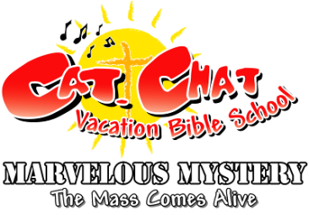
Child Registration Form .
Dates / Location: June 28-July 2 @ St. John Nepomucene Church
401 E. Lampasas, Ennis, TX
Contact: Annette Corbett Phone: 972-875-9650 E-mail: annettew@stjohncc.net
===================================================================================
Child’s Information:

Name: ____________________________________________________________________________________

Sex: (circle one) M F Age: _________________ Grade completed: ___________________

T-shirt size: (circle one) child sizes : S M L youth sizes: S M L

Allergies or medical conditions: ________________________________________________________________

Health Insurance # (if applicable): ______________________________________________________________

Family Information:

Parents/Guardians’ Name(s): __________________________________________________________________

Address: __________________________________________________________________________________

Phone Numbers:

Hm: _______________________ Wk: ________________________ Cell: ___________________________

Emergency Contact:

Name: ____________________________________________________________________________________

Phone: _________________________________

$10 per child, $5 for each additional child. Please do not let money be a hindrance to your child’s attendance – please speak with Annette if this is the case.

§
LIABILITY RELEASE: I understand that reasonable precautions will be taken to safeguard the health and well being of the participants in this VBS and that I will be notified as soon as possible in the event of an emergency. In the case of sickness or an accident, I authorize and consent the VBS Team, or other associated volunteers of the VBS program to obtain medical care from a licensed physician, hospital, or medical clinic for my son/daughter in the event that myself or other legal guardian(s) cannot be reached. I hereby do release and forever discharge this Diocese, and Parish from all manners of actions, claims which I or the child named above shall or may have for any reason, arising during my child’s attendance of the VBS.
Unless other written instruction is submitted, I also consent to allowing my child’s image to be recorded, either by photograph or video, and used during the VBS week or for future advertisement of Parish VBS programs. Any other use will require your further consent.

____________________________________________________________ __________________________________________
Parent / Guardian Signature Date

